Facebook network
1. Analyze the nodes centrality in each graph using different notions of centrality (e.g. degree centrality, betweenness centrality, eigenvector centrality etc.). What are the most central nodes in each graph? Why might that be the case?

Summary of Results
In the Facebook network (4039 nodes and 88,234 edges), we computed three types of centrality measures: degree centrality, betweenness centrality, and eigenvector centrality. The main results are summarized as follows:
The nodes with the highest degree centrality are 107, 1684, and 1912.
The nodes with the highest betweenness centrality are also led by node 107, followed by 1684, 3437, and 1912.
The node with the highest eigenvector centrality is 1912, followed by 2266 and 2206.
We observe that node 107 ranks first in both degree and betweenness centrality, whereas node 1912 ranks highest in eigenvector centrality.

Brief Analysis
The results show that different centrality measures capture different structural roles within the network.
Node 107 has the highest degree and betweenness centrality, indicating that it not only has a large number of direct connections but also serves as an important bridge between different subgroups. This suggests that node 107 plays a key structural role as a hub in maintaining connectivity across the network.
In contrast, node 1912 has the highest eigenvector centrality. Although it does not have the largest number of direct connections, it is connected to other highly central nodes. Therefore, its importance lies more in terms of influence within the core of the network rather than in sheer connectivity.
Overall, the results suggest that there are at least two types of central nodes in this Facebook network: highly connected structural hubs (such as node 107) and influential core members embedded within tightly connected communities (such as node 1912). Different centrality measures reveal distinct aspects of popularity, structural bridging, and influence within the network.

2. How many nodes are among the top 10% in terms of degree centrality AND betweenness centrality? How does this overlap change for each of these networks?
The overlap between the top 10% nodes ranked by degree centrality and betweenness centrality is 105 out of 403 nodes, corresponding to approximately 26%. This relatively modest overlap suggests that nodes with many direct connections are not necessarily the primary structural bridges in the network.
In other words, high-degree nodes often have many connections within a single community, while high-betweenness nodes may connect otherwise separate communities without necessarily having the largest number of direct links. This indicates the presence of modular structure in the Facebook network, where structural hubs and bridging nodes are not always the same individuals.
3. Perform community detection on these graphs. Investigate different community detection algorithms (e.g. “Louvain algorithm.” )Experiment with bounded and unbounded approaches. Visualize results.

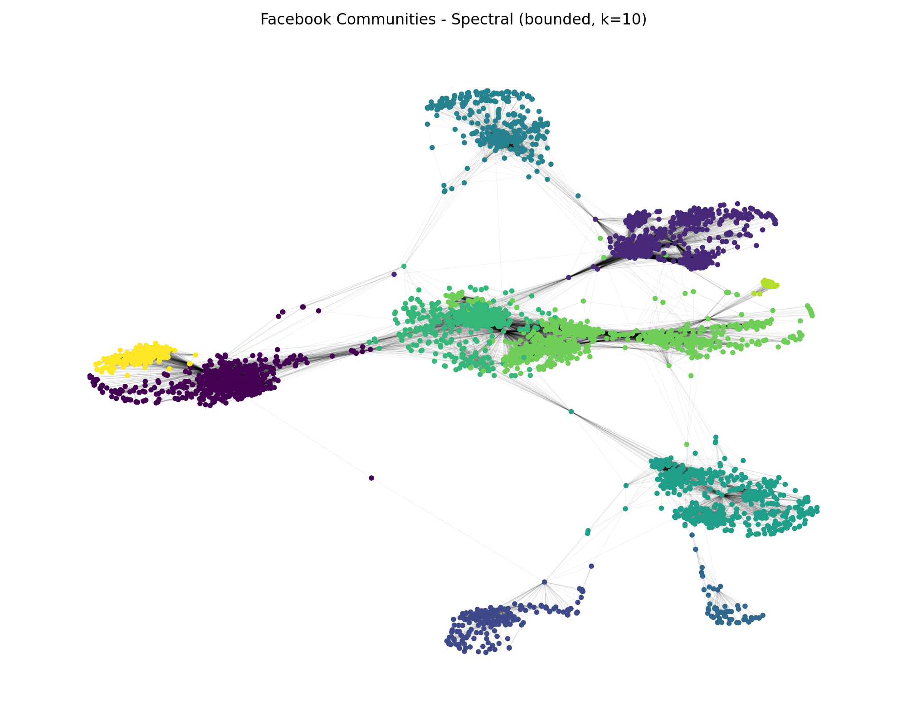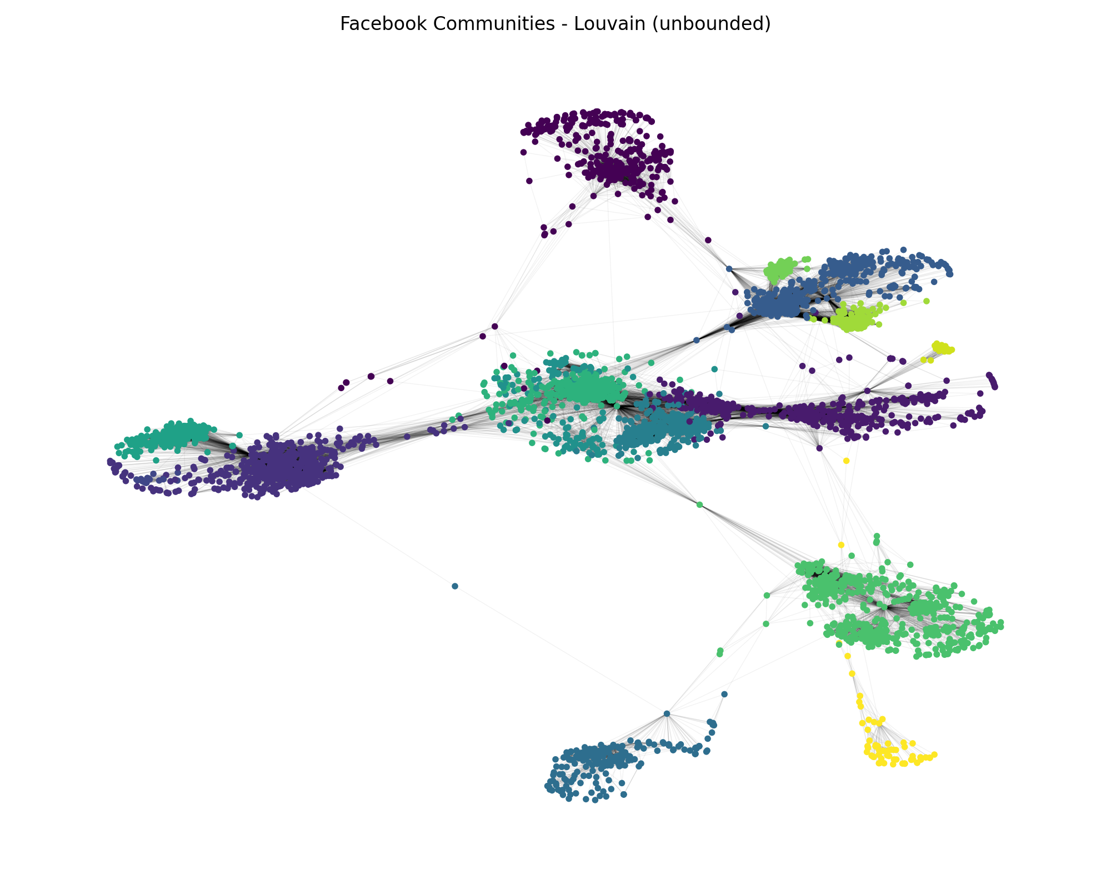
4. Analyze the communities formed as a result of the community detection algorithms. Why do certain nodes belong to the same community? For example, for the Erd¨os graph, one can analyze the top 5 authors with highest degree from the largest communities and check their research areas to see if they indeed have shared research interests
From the community detection results and the visualizations, it is evident that the Facebook network exhibits a clear community structure. Different colors represent different social subgroups. Nodes within the same community are densely connected, while connections between communities are relatively sparse, indicating a strong modular organization of the network.
Within each community, several high-degree nodes can be observed. These nodes are typically located near the center of the community, suggesting that they have relatively high social activity or influence within that group. For example, in Community 2, node 107 has an exceptionally high number of internal connections, indicating that it is likely a core member of that subgroup.
Further analysis shows that communities are not completely isolated from one another. Some nodes with high global betweenness centrality often serve as bridges between different communities. This suggests that certain highly popular nodes within one community may also be connected to core nodes in other communities, thereby forming cross-community bridge structures.
For instance, if the highest-degree node within one community is connected to a central node in another community, it implies that this node not only has strong influence within its own subgroup but also participates in multiple social circles, facilitating coordination or information flow across communities. Such a structure enhances the spread of information between different parts of the network.
Overall, the Facebook network demonstrates a typical social network pattern characterized by tightly connected communities internally and a small number of bridge nodes linking different communities together.
5. Analyze the degree distribution of these graphs. Do they follow a power law or a Poisson degree distribution? Why or why not?
The degree distribution of the Facebook network does not follow a Poisson distribution. In an Erdős–Rényi random graph, the degree distribution is approximately Poisson, meaning that the variance of the degree distribution is close to the average degree (Var(k) ≈ <k>). However, in this network, the variance of the degree distribution is much larger than the mean degree (Var(k) >> <k>). This indicates significant heterogeneity in node connectivity.
In addition, the network contains nodes with extremely high degrees (e.g., degree greater than 1000), while most nodes have relatively small degrees. This strong imbalance suggests the presence of hub nodes, which is inconsistent with a Poisson distribution where degrees are concentrated around the mean.
Instead, the degree distribution exhibits a heavy-tailed pattern and is approximately power-law–like in the upper tail. On a log–log scale, the complementary cumulative degree distribution (CCDF) appears roughly linear in the tail region, which is characteristic of power-law behavior. The estimated tail exponent is approximately alpha ≈ 2.6, which falls within the typical range observed in many real-world social networks.
This heavy-tailed structure arises from social network formation mechanisms such as preferential attachment (popular individuals tend to gain more connections) and triadic closure (friends of friends are likely to connect). Therefore, the Facebook network is better described as scale-free or power-law–like rather than Poisson.
6. Calculate the diameter and the average shortest path for these graphs. What can you notice?
For the Facebook network (4039 nodes and 88,234 edges), the diameter is 8 and the average shortest path length is approximately 3.69.
Despite the relatively large number of nodes, the average distance between any two nodes is fewer than four steps, and the maximum distance in the network is only eight steps. This indicates a clear small-world property, which is a well-known characteristic of social networks.
The small average shortest path length suggests the presence of highly connected hub nodes and cross-community bridge nodes. These nodes help reduce the overall distance between different parts of the network, enabling efficient connectivity and rapid information diffusion.
Although the network exhibits strong community structure, as observed in the previous community detection analysis, it remains globally well-connected. The relatively small diameter shows that communities are not isolated; instead, they are linked through bridging connections that maintain overall network cohesion.
Overall, the Facebook network demonstrates a typical small-world social network structure: short path lengths combined with modular community organization.
7. In terms of similarity and performance, how would you compare these graphs to Barabasi-Albert, Watts-Strogatz and Erd¨os-Renyi graphs? Justify your reasoning.
The Facebook network (n = 4039, m = 88,234) has an average degree of about 43.69. It also shows clear small-world behavior: the diameter is 8 and the average shortest path length is approximately 3.69. In addition, community detection yields high modularity (e.g., Louvain modularity ≈ 0.835), indicating strong modular/community structure. The degree distribution is highly heterogeneous: while the mean degree is about 43.69, the variance is much larger (Var(k) ≈ 2747.24), and the maximum degree is extremely large (k_max = 1045), which is inconsistent with a Poisson-like degree distribution.
Compared to Erdős–Rényi (ER): ER graphs typically have a Poisson degree distribution with Var(k) ≈ mean degree and low clustering/modularity. The Facebook network strongly deviates from this: Var(k) >> mean degree (2747.24 vs 43.69) and has very high modularity (≈ 0.835), implying pronounced community structure. Although ER graphs can also have short path lengths, ER cannot explain the simultaneous presence of hubs and strong community organization observed here.
Compared to Barabási–Albert (BA): BA graphs generate heavy-tailed degrees and hubs via preferential attachment, which matches the Facebook network’s strong degree heterogeneity (e.g., k_max = 1045). However, BA graphs typically do not produce clustering and modular community structure as strong as real social networks. The Facebook network’s high modularity (≈ 0.835) suggests that BA captures the hub effect but is insufficient to explain the strong community organization.
Compared to Watts–Strogatz (WS): WS graphs are designed to reproduce small-world structure (high clustering with short paths). The Facebook network’s small diameter (8) and low average shortest path length (≈ 3.69) align well with WS-like small-world behavior. However, WS does not naturally generate a heavy-tailed degree distribution, so it cannot fully capture the presence of extreme hubs (k_max = 1045) in the Facebook network.

